Sprint 2 Project
Hotel Bookings Management System
(HBMS)

Table of Contents
1 Introduction 3
1.1 Setup Checklist for Mini Project 3
1.2 Instructions Error! Bookmark not defined.
2 Problem Statement 4
2.1 Objective 4
2.2 Abstract of the project 4
2.3 Functional components of the project 4
2.4 Technology used: 5
3 Implementation 6
3.1 Summary of the functionality to be built: 6
3.2 Guidelines on the functionality to be built: 6

Introduction

This document outlines a case study for sprint 2 project. The project is to develop an online Hotel Bookings Management System (HBMS) for a website “LuxuryStays.com” as integration of all independent microservices. This document contains the work flow of the system and gives guidelines on how to build the functionality gradually in each of the course modules.

Setup Checklist for Mini Project
Minimum System Requirements
- Intel Pentium 90 or higher (P166 recommended)
- Microsoft Windows 95, 98, or NT 4.0, 2k, XP, Windows 7 or higher
- Memory: 8GB of RAM (8GB or more recommended)
- Internet Explorer 11.0 or higher or Chrome 55 or above
- JDK 8
- STS 3.9
- MAVEN
- Apache Tomcat

Software/Tool Requirement
- JDK 1.8
- IDE-STS(Spring Tool Suite)
- MAVEN
- PostMan Master
- GitHub- Version Control System
- MySql or H2 database
- IDE-Visual Studio Code

Problem Statement

Objective
Development of an online Hotel Bookings Management System (HBMS)

Abstract of the project
This project is aimed at developing an online Hotel Bookings Management System (HBMS). This is a web-based application that can be accessed over the web. This system can be used to search for Hotel rooms and reserve them. This is an integrated system that contains the microservices to achieve all the functionality for different components such as customer, hotel-employee and admin. There are features like to generate reports etc. in this system.

Functional components of the project
Following is a list of functionalities of the system. Wherever, the description of functionality is not adequate; you can make appropriate assumptions and proceed.

There are three categories of people who would access the system viz. customer, hotel-employee & Admin. Each one of them would have some exclusive privileges (for e.g. customer and hotel-employee can just search for hotel rooms and reserve them, but only the admin has the right to add new and modify hotels.)

- Customer and Hotel-Employee should be able to

  - Register into the system.
  - Login to the system using his/her credentials.
  - Search for hotel rooms.
  - Book hotel rooms.
  - View Booking Status

- The Admin should be able to

  - Login to the system using his/her credentials
  - Perform Hotel Management (add/delete/modify Hotel info like description, any special offers etc.)
  - Perform Room Management (add/delete/modify Room info like revised tariff)

  - Generate various reports like:
    - View List of Hotels
    - View Bookings of specific hotel
    - View guest list of specific hotels
    - View bookings for specified date

Technology used:
    - Front End & Web Components: –
      - Angular 6

    - Business Logic Components and Services: -
      - Java Beans
      - Microservices using Spring Boot

    - Application Servers: -
      - Apache Tomcat

    - Databases: -
      - H2 Database or MySQL

Implementation

Summary of the functionality to be built:
The participants need to develop the Online HBMS by building the functionality incrementally in each of the course modules.

Guidelines on the functionality to be built:
The functionality and components to be built are as follows:

- DATABASE DECISIONS:
- Create the following databases:
    - Users: This database contains the table of users with list of valid users with details
    - Hotel: This database will contain the tables such as HotelDetails and RoomDetails and the list of corresponding hotels and their corresponing rooms. These tables will be connected with a foreign key of hotelid inside RoomDetails table.
    - BookingDetails: This database will contain the table of booking details with list of booked rooms and their details.

- The structure of the above listed databases is as follows:
    - In User database table can be:
      - Users: user_id(varchar(4)), password (varchar(7)), role(varchar(10), user_name(varchar (20)), mobile_no(varchar(10)), email (varchar(15))
    - In Hotel database tables can be:
      - Hotel: hotel_id(varchar(4)), city (varchar(10)), hotel_name(varchar (20)), avg_rate_per-night (number(m,n)), phone_no1(varchar(10)), email (varchar(15))

      - Note : Description here could be a brief teaser about the hotel like – “Centrally located in the main city centre at Shivajinagar Railway Station, this budget accommodation is designed with spacious rooms…”. It could also give some special offers etc.

    - RoomDetails: hotel_id(varchar(4)), room_id (varchar(4)), room_type(varchar(20)), per_night_rate (number(6,2)), availability (Boolean), photo (blob))

    - Note : Room_type could be Standard non A/C room, Standard A/C room, Executive A/C room, Deluxe A/C room etc.

    - In BookingDetails database table can be:
      - BookingDetails: booking_id(varchar(4)), room_id(varchar(4)), user_id(varchar(4)), check_in(date), check_out(date), no_of_adults, no_of_children, amount(number(6,2))

Note: You may add/normalize/denormalize the tables if your application demands so.

- OOP & UML
  - Develop relevant Use case and Class diagrams for the HBMS application.

- ANGULAR & WEB BASICS
- Develop the following screens/components:
    - Home page screen: Home page for the online HBMS which provides a link for the login page.
    - Login Screen: Allows the valid user or amount to login to the system and display the Main option screen.
    - View Hotel screen: For all the users, this screen shows a list of hotels and rooms.
    - Book Rooms: For the customers and the hotel-employees, this screen will allow booking of available hotel rooms.
    - Add Hotels: This screen allows the admin to add new hotels or rooms.
    - Update Hotels: This screen allows the admin to update existing hotels or rooms.
    - Delete Hotels: This screen allows the admin to delete existing hotels or rooms.
    - View Reports: This screen offers administrator to view various reports by clicking on an appropriate link.

- In this course you need to develop the user interface using Angular 6 and web basics and document the flow of your application including the images of web page in a word document. The screens/web pages should include the fields as per the functionality mentioned above. Also, include client-side validations using in each of these screens

- JPA WITH HIBERNATE + SPRING BOOT + MICROSERVICES

HOTEL MANAGEMENT SYSTEM: This micro-service will communicate with the hotel management database which has two different tables of Hotels and Rooms.
This service will basically act as a mediator between Hotel Database and the Hotel Update Service, Hotel View Service, Room Update Service, Room View Service. This service will provide data only specific to services related to Hotel Management System.

HOTELS UPDATE SERVICE: This service is use to perform CRUD operations related to Hotel by an Admin. This service will communicate to Hotel Management Service to perform these operations. Following is a list of functionalities of the system:
  - Add Hotel details
  - Modify/Update Hotel details
  - Delete Hotel

HOTEL VIEW SERVICE: This micro-service is used for only view specific functionalities related to Hotels used by customers and admin and it’ll fetch the data from Hotel table with the help of Hotel Management Service
  - Display all Hotels
  - Search Hotels based on their cities and ratings

ROOM UPDATE SERVICE: This service is use to perform CRUD operations related to Rooms by an Admin. This service will communicate to Hotel Management Service to perform these operations. Following is a list of functionalities of the system:
- Add Room details
- Modify/Update Room details
- Delete Room

ROOM VIEW SERVICE: This micro-service is used for only view specific functionalities related to Rooms used by customers, employees and admin and it’ll fetch the data from Room table with the help of Hotel Management Service. Following is a list of functionalities of the system:
- Display all Rooms of a particular Hotel
- Search different types of rooms

BOOKING MANAGEMENT SERVICE: The functionality of this service is to integrate the different micro-services, i.e. Hotel Management and User Management service. The portal is created through which a customer and employee both can book rooms and admin can see all the booking details.

BOOKING UPDATE SERVICE: This micro-service is used to book rooms
- Customer & Employee can book rooms.

BOOKING VIEW SERVICE: This micro-service used to generate various reports like:
- Status of booking
- Bookings related to specific customer
- View All Bookings of a specific Hotels
- Booking on a specific date

USER MANAGEMENT SERVICE: This micro-service will communicate with the User management database and the Database contains the information about customers, employees. This service will basically act as a mediator between User Database and the User Update Service, User View Service. This service will provide data only specific to services related to User Management System.

USER UPDATE SERVICE: This micro-service is used to register a new user and perform operations like update, delete by customer and employee only. This service will communicate User Management Service to perform these operations.
- Register a user
- Modify/Update user details
- Delete user

USER VIEW SERVICE: The functionality of this service is to check whether the logged in user is an admin or an employee or a customer and redirect them to their respective portals where they will be able to perform the operations mentioned in the above micro-services and also provide registered customers and employees details to admin.
- Display all the customers
- Display all the employees
- Return role of different users

Epic & Stories

Epic | Stories | As a/an | I want to | So that ..
Hotel  Service | Add an Hotel | Admin | to enter the Hotel  details | A new Employee is added to the  employee database
Hotel  Service | Update an Hotel | Admin | to change the details entered  for the Hotel | To update the Hotel details in  the Hotel database
Hotel  Service | Delete an Hotel | Admin | To delete a Hotel | Hotel will be soft deleted from the Hotel database
Hotel  Service | Search an Hotel By City | Customer | To search a Hotel by City | Easy to find a Hotel from the entire database

Epic | Stories | As a/an | I want to | So that ..
Authentication  Service | Login into the system | Admin | Login as admin to the system | I can access admin services
Authentication  Service | Logout from the System | Admin | Logout from the system | I can logout from the system
Authentication  Service | Authorise Admin Request | Admin | To authenticate credentials | I can perform admin related Hotel/Room modifications
 | Authorize Customer Request | Customer | To authenticate credentials | I can perform Customer related modifications

Epic | Stories | As a/an | I want to | So that ..
Room Service | Add Room | Admin | to add Room. | Rooms can be inserted into Room database
Room Service | Get All Room | Admin | to get all the Rooms | get all rooms from database
Room Service | Update Room | Admin | To update the room | To update room details in the room database
 | Delete Room | Admin | To delete room by id | Hotel will be soft deleted from the Hotel database
 | Search Room | Customer/Admin | To search a room by id | Easy to find a Hotel from the database

Epic | Stories | As a/an | I want to | So that ..
Booking  Service | Add an Booking | Customer | Enter the Booking details | A new Booking is added to the Booking  database
Booking  Service | Get all Booking | Admin | to get all the booking from  database | get booking from database
Booking  Service | Get Booking By Id | Admin | to get the booking by id | Easy to find a booking from database
Booking  Service | Delete Booking By Id | Admin | to delete the booking by id | booking will be soft deleted from the booking database
 | Get Booking by Hotel Name | Admin | To get booking by hotel name | Easy to find a booking from database

Use Case Diagram:
1.Room Service

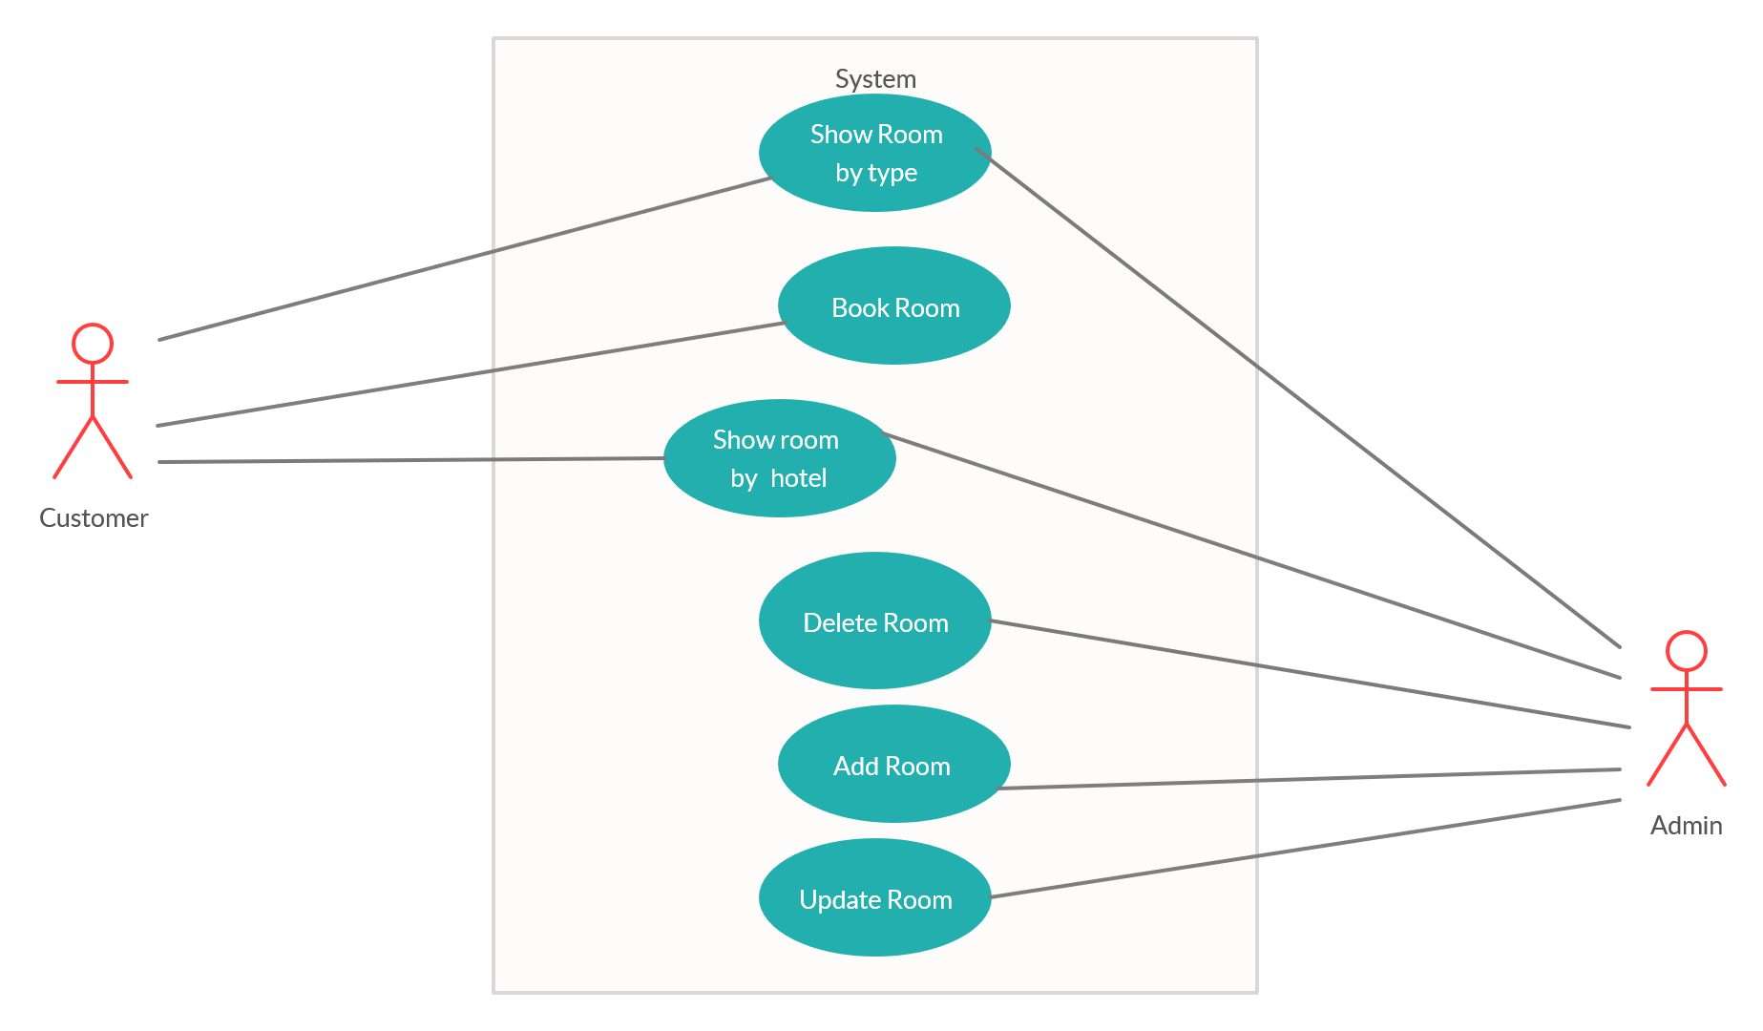

2.Hotel Service

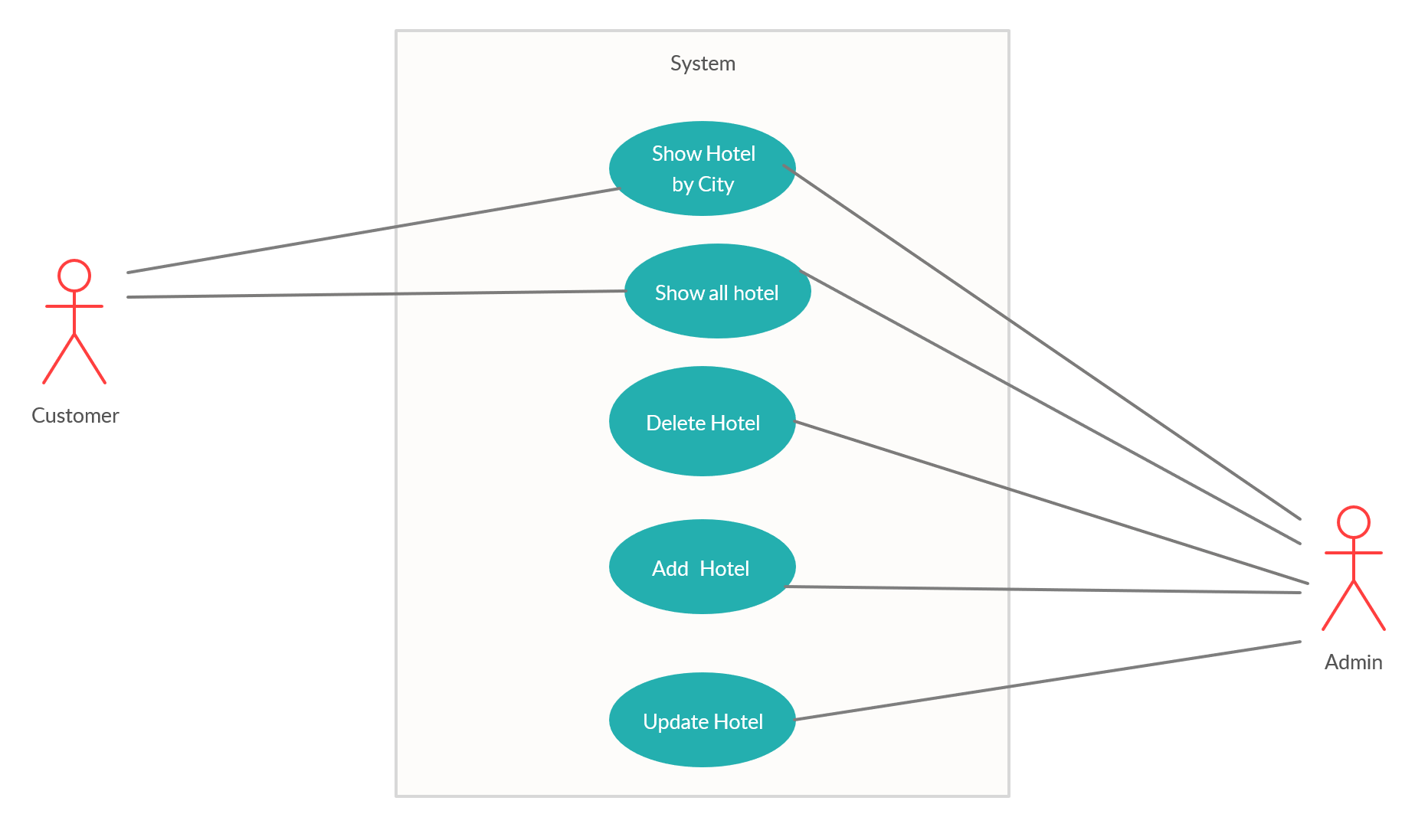

3.Booking Service
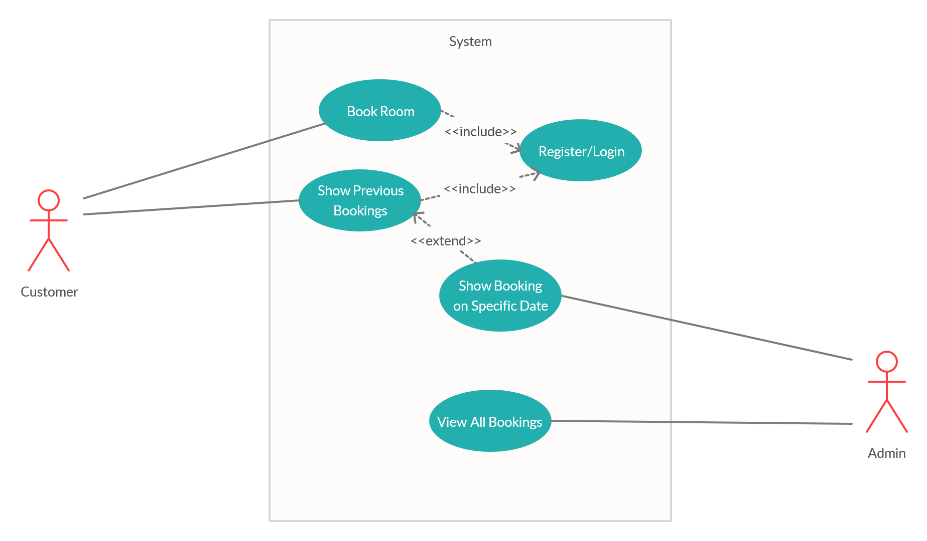

4.Authentication Service
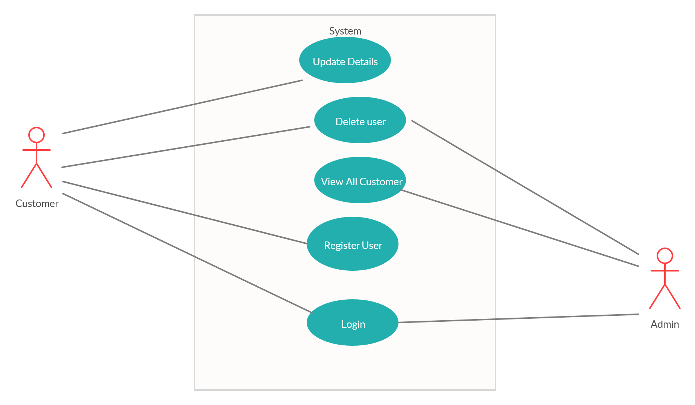

Class Relationship Diagram:
1.Authentication Service

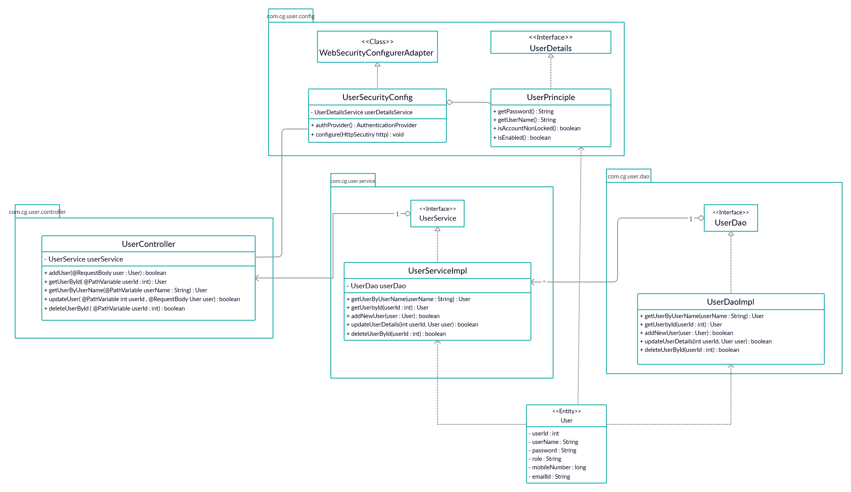

2.Booking Service

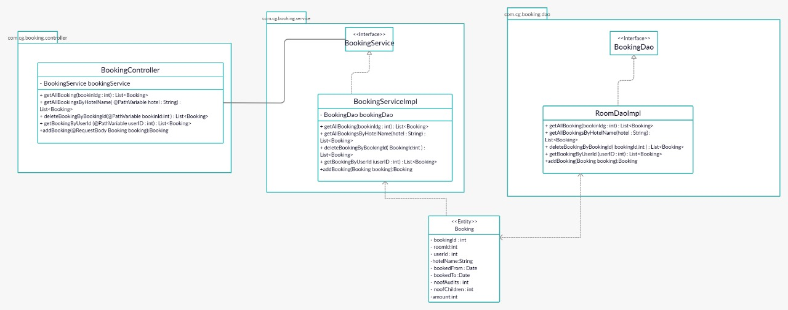

3.Hotel Srevice

4.Room Service

